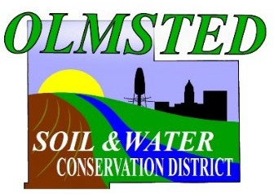March 27, 2025

## OLMSTED SOIL AND WATER CONSERVATION DISTRICT

**2122 Campus Drive SE, Suite 200 Rochester, Minnesota 55904**

**Phone: (507) 328-7070**

Dear 2025 SWCD **Tree Sale** Customers,

The 2025 Olmsted SWCD Annual Tree Sale Pickup will take place on:

# Friday, April 25, 2025 from Noon - 7:00 PM

* **Graham Park/Olmsted Co Fairgrounds - Building 25 (Dairy)**

## Building 25 (Dairy) is located on the south side of the fairgrounds. ADDRESS: 25 Arena Drive SE Rochester MN 55904

**The closest access points are off 16th St SE.**

**\*Please note: this pickup is for TREE ORDERS only.** If you purchased plant kits and seed mixes the pickup for that will take place in mid-May. Another communication will be sent closer to that date. Visit our website to purchase your plant kits or seed mixes!! Visit the sale at: [www.olmstedswcd.org](http://www.olmstedswcd.org/)

Unsold trees, if available, will be sold on a first come, first serve basis by personal check only. Checks can be made payable to: Olmsted County.

If questions, contact us at: 507-328-7070. Thank you and see you on April 25th! Sincerely,

Skip Langer

Olmsted Soil and Water Conservation District Manager